Article

A Smart System for Continuous Sitting Posture Monitoring and Assessment

David Faith Odesola 1, Janusz Kulon 1* and, Shiny Verghese 1, Adam Partlow 2, and Colin Gibson 2

|  |
| --- |
| **Citation:** To be added by editorial staff during production.  Academic Editor: Firstname Lastname  Received: date  Revised: date  Accepted: date  Published: date    **Copyright:** © 2024 by the authors. Submitted for possible open access publication under the terms and conditions of the Creative Commons Attribution (CC BY) license (https://creativecommons.org/licenses/by/4.0/). |

1 Faculty of Computing, Engineering and Science, University of South Wales, Pontypridd, CF37 1DL, UK; 30025293@students.southwales.ac.uk; j.kulon@southwales.ac.uk; shiny.verghese@southwales.ac.uk

2 Rehabilitation Engineering Unit, Cardiff and Vale University Health Board, CF37 5TF, UK

Adam.Partlow@wales.nhs.uk; Colin.Gibson@wales.nhs.uk

* Correspondence: j.kulon@southwales.ac.uk

**Abstract: <<**TO BE FILLED>>.

**Keywords:** sitting posture classification, smart-sensing chair, machine learning, posture monitoring

1. Introduction

1.1 Background and Motivation

In this present day and age, sedentary behaviors such as sitting has become a fundamental part of one’s lifestyles, especially among office workers. These individuals often find themselves confined to a desk, in front of a computer screen for an extended period; a pattern that has proven to be detrimental to one’s health [1,2]. According to the World Health Organization (WHO), the economic burdens attributed to sedentary behaviors is costing around US$ 27 billion annually and is expected to reach US $300 billion by the year 2030 [3].

The adoption of an improper sitting postures such as slouching and asymmetric sitting is a contributing factor that further increases the risk of several health issues, ultimately negatively affecting the quality of life. This bad habit is not just prevalent among the elderly population, but also across individuals within different age groups [4]. Over a long-term period, this could thereby lead to the development of chronic health issues such as lower back pains [5] and other musculoskeletal conditions [6]. Hence, it is naturally advised by doctors and healthcare professionals to consistently maintain an upright sitting posture by having your back in a straight position or perpendicular to the seat’s backrest. Furthermore, in addition to maintaining an upright sitting posture, it is also recommended to avoid sitting for a long period of time or maintaining a singular posture for a long duration [7,8]. Additionally, it is advised to take squeeze in a few walking breaks after a given period.

Furthermore, to help combat this issue, various researchers have explored the use of smart sensing chair systems which are capable of can detect various sitting postures, thereby guiding the end user to enforce proper sitting habits. So far, various methods have been employed in the development of such systems ranging from different classification methods, sensor placement configuration, and sensor types. A recent study by [9] highlighted a gap in the current research landscape which found that the vast majority of the similar studies primarily focus just on the detection of different sitting postures and achieving high classification accuracy. There is no doubt that there are integral in the development of such system, however there is more that can be done in improving the feedback mechanism that is bring provided back to the end user, subsequently encouraging and motivating them to adopt proper sitting postures.

1.2 Objective of the Study

The aim of this study is to develop a robust machine-leaning model capable of detecting different sitting postures as well as creating a comprehensive posture monitoring system that not only classifies different sitting postures, but also intelligently scores them. Additionally, this study also looks provide real-time feedback system which would display relevant statistical insights based on the posture dataset back to the end-user.

2. Related Works

Over the recent years, there has been a constant rise in the amount of research studies conducted on sitting posture detection and monitoring system. This growing attention among researchers highlights this research’s potential of driving significant change by positively impacting postural habits among individuals, subsequently improving the quality of life [9]. Currently, there are 2 main categories of posture monitoring devices, which are wearable devices and non-wearable devices.

Wearable devices are systems which are fitted with sensors which must be always worn in order to capture real-time postural readings, mainly focusing on the spinal area. These sensors are typically small and are often integrated into clothing wear which must constantly have bodily contact. Due to its highly invasive nature, many individuals may find it quite uncomfortable and disruptive to their daily activities. In terms of the practicality of such systems among the general population, it is of great importance consider areas such energy consumption, portability and its non-invasiveness [10]. Inertial sensors such as IMUs (Inertial Measurement Unit) which are normally comprised of gyroscopes, accelerometers and sometimes magnetometers are popularly used to capture an individual’s bodily measurements. A gyroscope measures the angular postural velocity across all axes, accelerometers capture the rate of change in acceleration, while magnetometers measure the Earth’s magnetic field which provides information in determining the orientation. The combination of all 3 sensors creates a compressive picture of one’s current posture and bodily movement within a 3D space [11].

On the other hand, there are the non-wearable solutions which do not require an individual to wear any special clothing or device. These systems are non-invasive by nature are meant to capture postural measurements without being disruptive towards the end user in any way. Within this research field, there are various methods being employed such as the use of camera-based systems and sensor-infused sitting mats. Camera-based systems work by a having a set of cameras which meant to capture multiple reference points of the human body such as the head, shoulders and the hips. This typically functions by having one or more cameras placed at different point of view to effectively capture all the bodily points. For this to work effectively, there must be no obstruction between the camera’s view and the subject being assessed, and there must always be proper lighting available. Overall, this suggests that the viability of camera-based systems primarily depends on a properly controlled environment, making it an un-popular option among research studies [10]. Meanwhile, a more common method is the use of sensor-infused sitting mats which goes notion of having one or more sensors integrated into the backrest and the seating area of a seat. As the user seats and subtly moves about the chair, the system can both capture and identifying the different postures being adopted. Some of the commonly used sensors are pressure sensors, load cells, and flex sensors. One of the first research papers published that pioneered the idea of a smart sensing chair system was by Tan el. [12] back in 2001. They were able to classify 14 different siting postures using a (Principal Component Analysis)-based algorithm which interfaced with pressure sensor array module placed the both the back rest and the sitting area of the chair; achieving an overall accuracy ranging between 79% to 96%. Subsequently, a lot of research studies has been published primarily following a very similar approach. This research paper will be focusing on this approach and will be highlighting the common methods being used and the current research landscape within this field.

2.1 Sensor Technology

The sensor being used is one of the key components of a smart sensing chair systems, as it plays a key role in capturing one’s sitting pattern which would subsequently be classified by a detection algorithm. As previously highlighted, among research studies, here are different sensors being used such as pressure sensors, load cells, flex sensors, and distance sensors, According to a literature review study by Odesola et al. in 2024 [9], the pressure sensor was seen as the most popular option among related studies.

Wang et al. [13] developed a smart chair system equipped with 2 (9x9) & (10x9) FSR pressure matrix which were used to classify up to 15 different sitting postures using the SNN (Spike Neural Networks). Tsai et al. adopted a similar approach by using a textile-based pressure sensor array in order to classify 7 sitting postures while achieving an overall classification accuracy of 85.9%.

2.2 Posture classification techniques

**Figure 1**. Different classification techniques being adopted

Over the years, there have been various types of machine learning models being used to classify a wide range of sitting postures; ranging from statistical models to deep learning models. Jeong et al. [14] using the KKN (K-Nearest Neighbor) algorithm to classify

It was also seen as the number of sitting postures increases, the less accurate the machine learning model performance tends to be. This might be largely due to the similarities in shape between each posture, making it difficult for the machine learning model to distinguish each one of them. [Add Reference]

2.3 Feedback Mechanism

There is no doubt that achieving high posture classification accuracy is crucial among smart sensing chair systems. However, this alone doesn’t bring any value back to the end user. What is also needed is a feedback mechanism that would both inform and encourage the end user to adopt “proper” sitting postures while also providing valuable insights that would improve their overall sitting pattern. Whenever a bad sitting posture is detected for a long duration of time, the user should be alert in one way or another to correct it. Within the current research landscape, there are multiple ways that a user could be alerted. Mobile phones have been emerging as a popular medium for collecting and displaying useful feedback back to the end user. Cai et al. [15] developed a smart sensing chair system which relayed the detected posture via a mobile app. Additionally, Cho et al [16] also developed a similar mobile app which provided statistical insights along with recommended YouTube videos largely based on the sitting postures being adopted.

There are also other ways that the end user could be notified or alerted whenever an incorrect sitting posture is being adopted. Ran et al. [17] and Ishac et al. [18] integrated haptic motors into the seating cushion which vibrated whenever an improper sitting posture is being detected which continues until an upright posture has been achieved by the individual. On the other hand, Ren et al. [19] incorporated the use of a RGB led light strip which changed in color whenever the individual needed to change their sitting posture and taking microbreaks.

Overall, it was seen that the feedback mechanism implemented among many similar studies were severely lacking mainly in providing informative elements and actionable insights. Ideally this should encourage individuals o both adopt and maintain proper sitting postures. However, most systems are more focused on simply displaying the current posture being adopted without any form of valuable feedback mechanism. While most smart-sensing systems can detect and identify various sitting postures, there are some feature sets that are absent such as real-time feedback and posture scoring mechanism which would rate and provide a score on the current posture being adopted. From the end user’s perspective, is there any certainty that the implemented feedback system has achieved its goal of inciting adopting of proper sitting postures? Furthermore, with the lack of comprehensive feedback of such systems, a lot of questions can be raised regarding both its usability and effectiveness in a real-life setting. Hence, there is a need for a comprehensive system in place to access whether the implemented feedback mechanism as achieved its desired expectations.

3. Methodology

In this paper, a smart sensing chair system is developed classify different sitting postures using a FSR pressure sensor array. This study will be focusing on 5 sitting postures with are upright, slouching, leaning right, leaning left, leaning back as shown in Figure 1. Additionally, a novel feedback software application will be developed to provide valuable health insights which aims to encourage the end user to adopt proper sitting postures.

In order to capture the entire sitting posture of an individual, 2 (32x32) CONFORMat pressure sensor arrays which will be placed on the backrest and the seating cushion of the chair. The pressure sensor mat was developed by a company called Tekscan who specializes in the manufacturing of pressure measure sensor units [20].

**Figure 2**. 5 different sitting postures. (SP1) Upright, (SP2) Slouching, (SP3) Leaning Left, (SP4) Leaning Right, (SP5) Leaning Back.

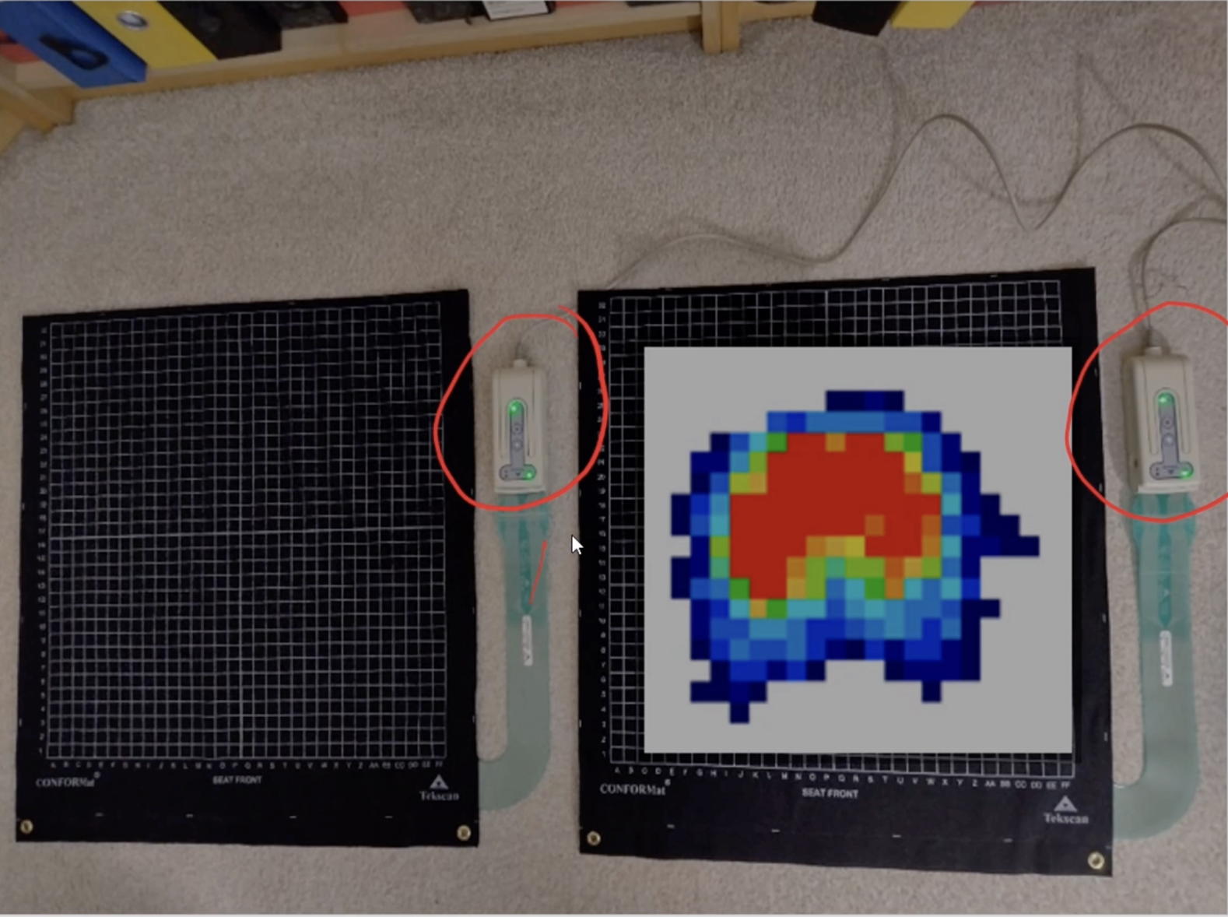

**Figure 3**. 2 (32x32) Tekscan Pressure Sensor Array Mat

3.1 Data Collection

3.1.1 Participants

3.1.2 Experimental Setup

Java 2 
GORITHMS 

**Figure 4**. Office chair fitted with 2 Tekscan Pressure Mats.

3.2 Machine Learning Algorithm

Data augmentation

**Figure 5**. Data Augmentation Samples for the Right Leaning Posture.

Data scaling

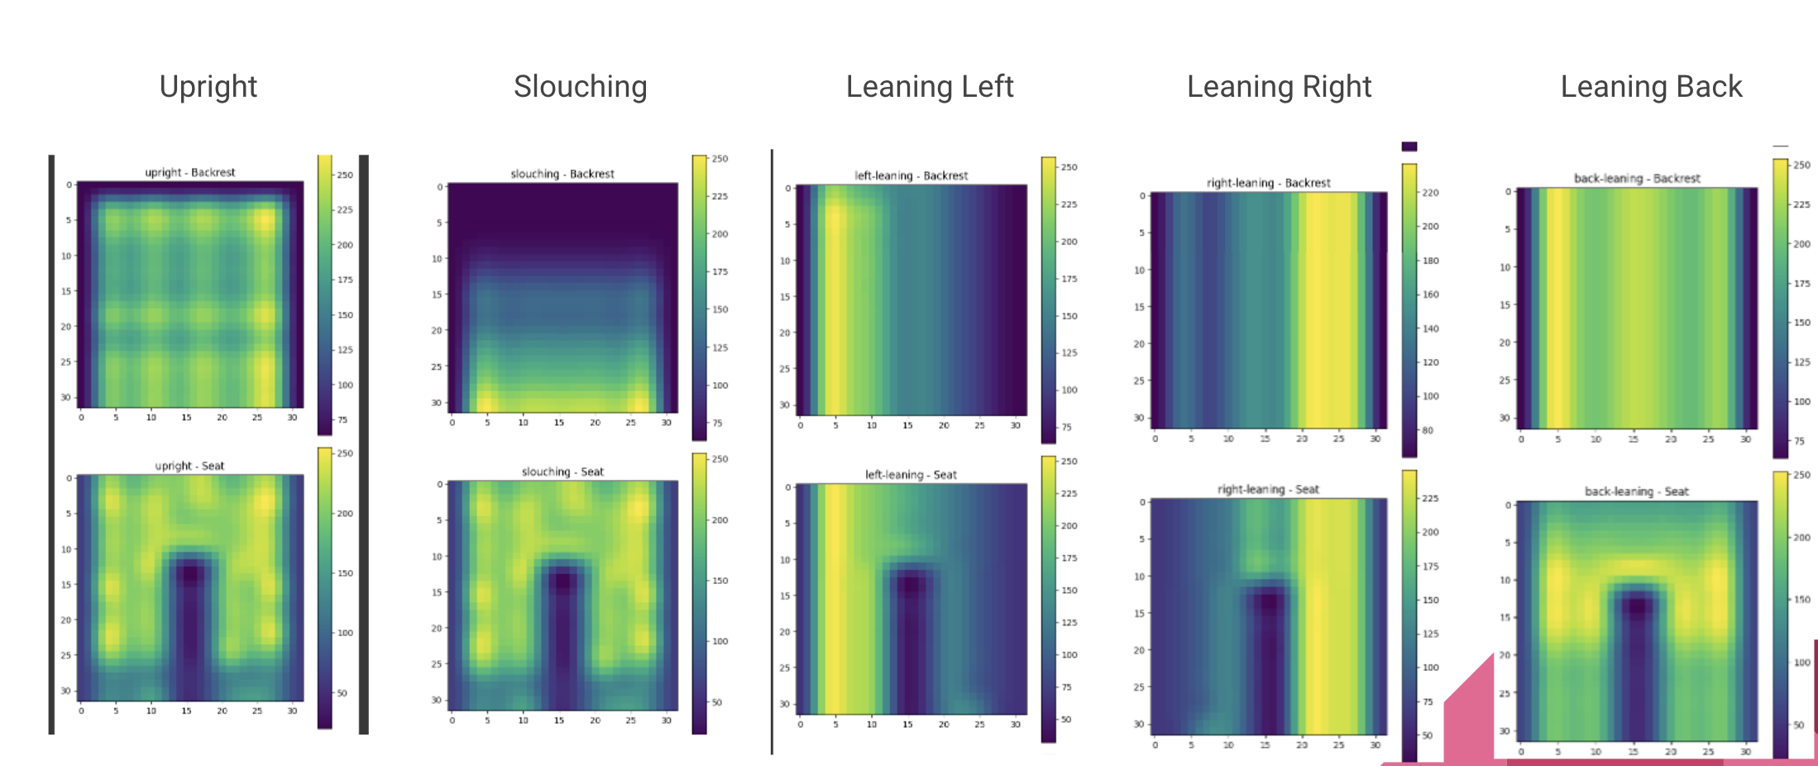

3.3 Posture Monitoring and Scoring System

4. Results and Discussion

4.1 Performance of the Machine Learning Algorithm

4.2 Effectiveness of the Posture Monitoring System

4.3 Statistical Analysis of Sitting Patterns

4.4 Interpretation of Results

4.5 Limitations of the Study

4. Discussion

5. Conclusions

This is the conclusion section

**Supplementary Materials:** The following supporting information can be downloaded at: www.mdpi.com/xxx/s1, Figure S1: title; Table S1: title; Video S1: title.

**Author Contributions:** <Author’s contributions>

**Funding:** This work was partly supported by the University of South Wales (USW) QR fund (ref: 104607.13.1125), RIS funding (ref: 104790.1125), and Cardiff & Vale University Health Board, Rehabilitation Engineering Unit (REU), contributions (ref: 103914.13.1122).

**Institutional Review Board Statement:** Not Applicable.

**Informed Consent Statement:** Not Applicable.

**Data Availability Statement:** We encourage all authors of articles published in MDPI journals to share their research data. In this section, please provide details regarding where data supporting reported results can be found, including links to publicly archived datasets analyzed or generated during the study. Where no new data were created, or where data is unavailable due to privacy or ethical restrictions, a statement is still required. Suggested Data Availability Statements are available in section “MDPI Research Data Policies” at https://www.mdpi.com/ethics.

**Acknowledgments:** The authors would like to thank the University of South Wales and Cardiff & Vale University Health Board, REU, for supporting the project.

**Conflicts of Interest:** The authors declare no conflicts of interest.

**Appendix A**

Appendix content

**Appendix B**

Appendix content

References

1. Daneshmandi, H.; Choobineh, A.; Ghaem, H.; Karimi, M. Adverse Effects of Prolonged Sitting Behavior on the General Health of Office Workers. *J Lifestyle Med* **2017**, *7*, 69–75, doi:10.15280/jlm.2017.7.2.69.

2. Keskin, Y. Correlation between Sitting Duration and Position and Lumbar Pain among Office Workers. *Haydarpasa Numune Med J* **2019**, doi:10.14744/hnhj.2019.04909.

3. *Global Status Report on Physical Activity 2022*; World Health Organization: Geneva, 2022; ISBN 978-92-4-005915-3.

4. Yang, L.; Lu, X.; Yan, B.; Huang, Y. Prevalence of Incorrect Posture among Children and Adolescents: Finding from a Large Population-Based Study in China. *iScience* **2020**, *23*, 101043, doi:10.1016/j.isci.2020.101043.

5. Kett, A.R.; Sichting, F.; Milani, T.L. The Effect of Sitting Posture and Postural Activity on Low Back Muscle Stiffness. *Biomechanics* **2021**, *1*, 214–224, doi:10.3390/biomechanics1020018.

6. Susilowati, I.H.; Kurniawidjaja, L.M.; Nugraha, S.; Nasri, S.M.; Pujiriani, I.; Hasiholan, B.P. The Prevalence of Bad Posture and Musculoskeletal Symptoms Originating from the Use of Gadgets as an Impact of the Work from Home Program of the University Community. *Heliyon* **2022**, *8*, e11059, doi:10.1016/j.heliyon.2022.e11059.

7. Stephens, M.; Bartley, C.A. Understanding the Association between Pressure Ulcers and Sitting in Adults What Does It Mean for Me and My Carers? Seating Guidelines for People, Carers and Health & Social Care Professionals. *Journal of Tissue Viability* **2018**, *27*, 59–73, doi:10.1016/j.jtv.2017.09.004.

8. Benatti, F.B.; Ried-Larsen, M. The Effects of Breaking up Prolonged Sitting Time: A Review of Experimental Studies. *Medicine & Science in Sports & Exercise* **2015**, *47*, 2053–2061, doi:10.1249/MSS.0000000000000654.

9. Odesola, D.F.; Kulon, J.; Verghese, S.; Partlow, A.; Gibson, C. Smart Sensing Chairs for Sitting Posture Detection, Classification, and Monitoring: A Comprehensive Review. *Sensors* **2024**, *24*, 2940, doi:10.3390/s24092940.

10. Vermander, P.; Mancisidor, A.; Cabanes, I.; Perez, N. Intelligent Systems for Sitting Posture Monitoring and Anomaly Detection: An Overview. *J NeuroEngineering Rehabil* **2024**, *21*, 28, doi:10.1186/s12984-024-01322-z.

11. Simpson, L.; Maharaj, M.M.; Mobbs, R.J. The Role of Wearables in Spinal Posture Analysis: A Systematic Review. *BMC Musculoskelet Disord* **2019**, *20*, 55, doi:10.1186/s12891-019-2430-6.

12. Tan, H.Z.; Slivovsky, L.A.; Pentland, A. A Sensing Chair Using Pressure Distribution Sensors. *IEEE/ASME Trans. Mechatron.* **2001**, *6*, 261–268, doi:10.1109/3516.951364.

13. Wang, J.; Hafidh, B.; Dong, H.; El Saddik, A. Sitting Posture Recognition Using a Spiking Neural Network. *IEEE Sensors J.* **2021**, *21*, 1779–1786, doi:10.1109/JSEN.2020.3016611.

14. Jeong, H.; Park, W. Developing and Evaluating a Mixed Sensor Smart Chair System for Real-Time Posture Classification: Combining Pressure and Distance Sensors. *IEEE J. Biomed. Health Inform.* **2021**, *25*, 1805–1813, doi:10.1109/JBHI.2020.3030096.

15. Cai, W.; Zhao, D.; Zhang, M.; Xu, Y.; Li, Z. Improved Self-Organizing Map-Based Unsupervised Learning Algorithm for Sitting Posture Recognition System. *Sensors* **2021**, *21*, 6246, doi:10.3390/s21186246.

16. Cho, H.; Choi, H.-J.; Lee, C.-E.; Sir, C.-W. Sitting Posture Prediction and Correction System Using Arduino-Based Chair and Deep Learning Model. In Proceedings of the 2019 IEEE 12th Conference on Service-Oriented Computing and Applications (SOCA); IEEE: Kaohsiung, Taiwan, November 2019; pp. 98–102.

17. Ran, X.; Wang, C.; Xiao, Y.; Gao, X.; Zhu, Z.; Chen, B. A Portable Sitting Posture Monitoring System Based on a Pressure Sensor Array and Machine Learning. *Sensors and Actuators A: Physical* **2021**, *331*, 112900, doi:10.1016/j.sna.2021.112900.

18. Ishac, K.; Suzuki, K. LifeChair: A Conductive Fabric Sensor-Based Smart Cushion for Actively Shaping Sitting Posture. *Sensors* **2018**, *18*, 2261, doi:10.3390/s18072261.

19. Ren, X.; Yu, B.; Lu, Y.; Chen, Y.; Pu, P. HealthSit: Designing Posture-Based Interaction to Promote Exercise during Fitness Breaks. *International Journal of Human–Computer Interaction* **2019**, *35*, 870–885, doi:10.1080/10447318.2018.1506641.

20. Tekscan Tekscan Available online: https://www.tekscan.com (accessed on 8 October 2024).

**Disclaimer/Publisher’s Note:** The statements, opinions and data contained in all publications are solely those of the individual author(s) and contributor(s) and not of MDPI and/or the editor(s). MDPI and/or the editor(s) disclaim responsibility for any injury to people or property resulting from any ideas, methods, instructions or products referred to in the content.